**Chapter 6 - Quiz**

1. Match the items to the targets determining support for VLSM.
2. RIP v1 Protocols that do not support VLSM
3. EIGRP Protocols that support VLSM
4. IGRP Protocols that do not support VLSM
5. IS-IS Protocols that support VLSM
6. OSPF Protocols that support VLSM
7. RIP v2 Protocols that support VLSM
8. Match the description to the appropriate term. (Not all options are used.)
9. Ability to divide one IP address into different subnets.
10. Combining several IP network addresses in one IP address. Route summarization
11. Ability to specify a different subnet mask for the same network  
    number and different subnets. VLSM
12. Also known as supernetting. Route summarization
13. Conserves address space. VLSM
14. Used to reduce the number of entries in a routing table. Route summarization
15. What two methods were used to allow the continued use of IPv4 addressing when the available hosts were exhausted? (Choose two.)
16. Variable length subnetting.
17. The IPv4 address range was expanded.
18. Private addresses were used with address translation.
19. Classful routing was implemented.
20. IPv4 was abandoned in favor of IPv6 for all hosts.
21. Supernetting was implemented.
22. The following subnet masks have been chosen for use with the 192.168.16.0 network:

255.255.255.252

255.255.255.240

255.255.255.192

Which three approaches identify the most efficient use for each of these masks? (Choose three.)?

1. Use the /30 mask for point-to-point links, such as WAN connections.
2. Use the /30 mask for subnetworks of four or more hosts.
3. Use the /28 mask for small subnetworks with up to 14 hosts.
4. Use the /26 mask for larger subnetworks with up to 62 hosts.
5. Use the /25 mask for subnetworks with up to 30 hosts.
6. Use the /24 mask for point-to-point links, such as WAN connections.
7. When using a classful class A IP address scheme, how many octets are used to designate the network portion of the address?
8. 1
9. 2
10. 3
11. 4
12. Select the VLSM subnets of the 172.16.0.0 network that will simultaneously provide the total number of required hosts on each subnet? Match the subnet with the number of required hosts. Not all options are used.?

|  |  |  |
| --- | --- | --- |
| 1. 172.16.64.0 /18 | ⬄ | 16.000 hosts |
| 1. 172.16.16.64 /30 | ⬄ | 2 hosts |
| 1. 172.16.128.0 /19 | ⬄ | 8.000 hosts |
| 1. 172.16.144.0 /25 | 🞬 |  |
| 1. 172.16.18.0 /24 | ⬄ | 250 hosts |
| 1. 172.16.5.128 /26 | ⬄ | 60 hosts |
| 1. 172.16.10.128 /28 | 🞬 |  |

1. Refer to the two groups of subnets listed below. A network engineer is summarizing the two groups of router R1 shown. Which summarization works for all the subnets?

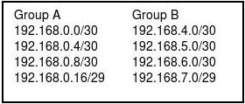

1. 192.168.0.0 /23
2. 192.168.0.0 /22
3. 192.168.0.0 /21
4. 192.168.0.0 /20
5. How many bits are used in the IPv4 address space?
6. 8
7. 12
8. 16
9. 30
10. 32
11. 64
12. Match each address to the appropriate address class. Not all items are used.
13. 192.14.0.0 Class C address
14. 191.254.45.0 Class B address
15. 123.90.78.45 Class A address
16. 128.44.0.23 Class B address
17. 129.68.11.45 Class B address
18. 126.0.0.0 Class A address
19. 198.162.11.0 Class C address
20. 125.33.23.56 Class A address
21. Refer to the following topology description to answer the question.

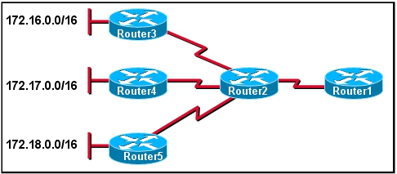

The network administrator wants to minimize the number of entries in Router1's routing table. What should the administrator implement on the network?

1. VLSM
2. CIDR
3. private IP addresses
4. classful routing